Charles Bailey

CMPT 390

Spring 2015

Abstract

The purpose and objective in developing this app was to provide principals working in Uinta County School District # 1 with a convenient tool to evaluate and provide feedback to teachers. One of the most important requirements in creating this app was to give principals flexibility in choosing which criteria they wanted to use for each evaluation, as many apps with similar purposes do not provide flexibility. By developing this app, I will gain experience with Objective C and Xcode, as well as gain skills interacting with users and demonstrating software to the users who will use it.

Introduction

The Teacher Evaluation App is an app that allows principals in Uinta County School District #1 to use Iphones and Ipads to take notes for teachers, rate the teachers, and then provide feedback to the teachers while tracking the progress of a teacher throughout the school year. My father is a Superintendent for Uinta County School District and needed someone to develop this application. Using a curriculum from the University of Washington, a principal will chose certain criteria and give a rating on a four point scale from emerging to distinguished, or choose the option on N/A for criteria that do not apply to the current evaluation. The principal will also be able to take notes that would be most useful during a lesson the teacher is giving. The ratings will be stored in the application, but the principal will only send written feedback through email. Since it can be hard for anyone to see ratings, and even more difficult to deal with lower ratings, the principal will only give written feedback about where the teacher needs to improve. The notes and ratings will be saved and can be a reference to see if the teacher is improving the quality of the education provided to the students.

Implementation

The Teacher Evaluation App is an IOS application built in Xcode. I chose to use Xcode because I was first introduced to it back in the IOS Mayterm class in May 2014. My father also wanted an application that can be used with IOS devices, as principals will find using Iphones and Ipads easier and more convenient in a classroom setting. Since I had some familiarity with it from May, I felt comfortable programming in Objective C. While I had to learn many things about implementing Objective C, Xcode also provided a simulator that allowed me to see how the app would run on an actual IOS device. Xcode also allows programmers to visually create the screens without code, and link objects such as buttons, labels, and text fields to the Objective C files, as shown below.

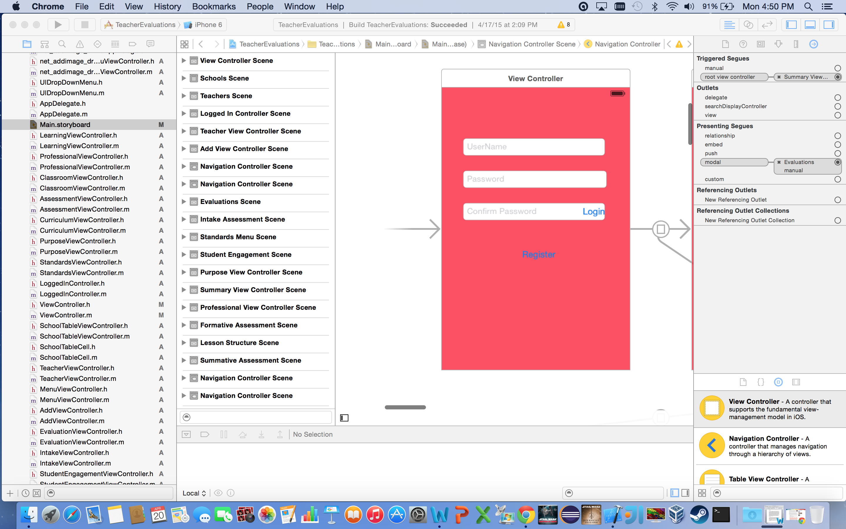

Xcode also has segues that connect screens and enable hand swipes or buttons to get a user from one screen to the next. Navigation View Controllers are automatic view controllers that allow a navigation view at the top of an IOS screen. Below is an image of the screens that were created and how they are connected.

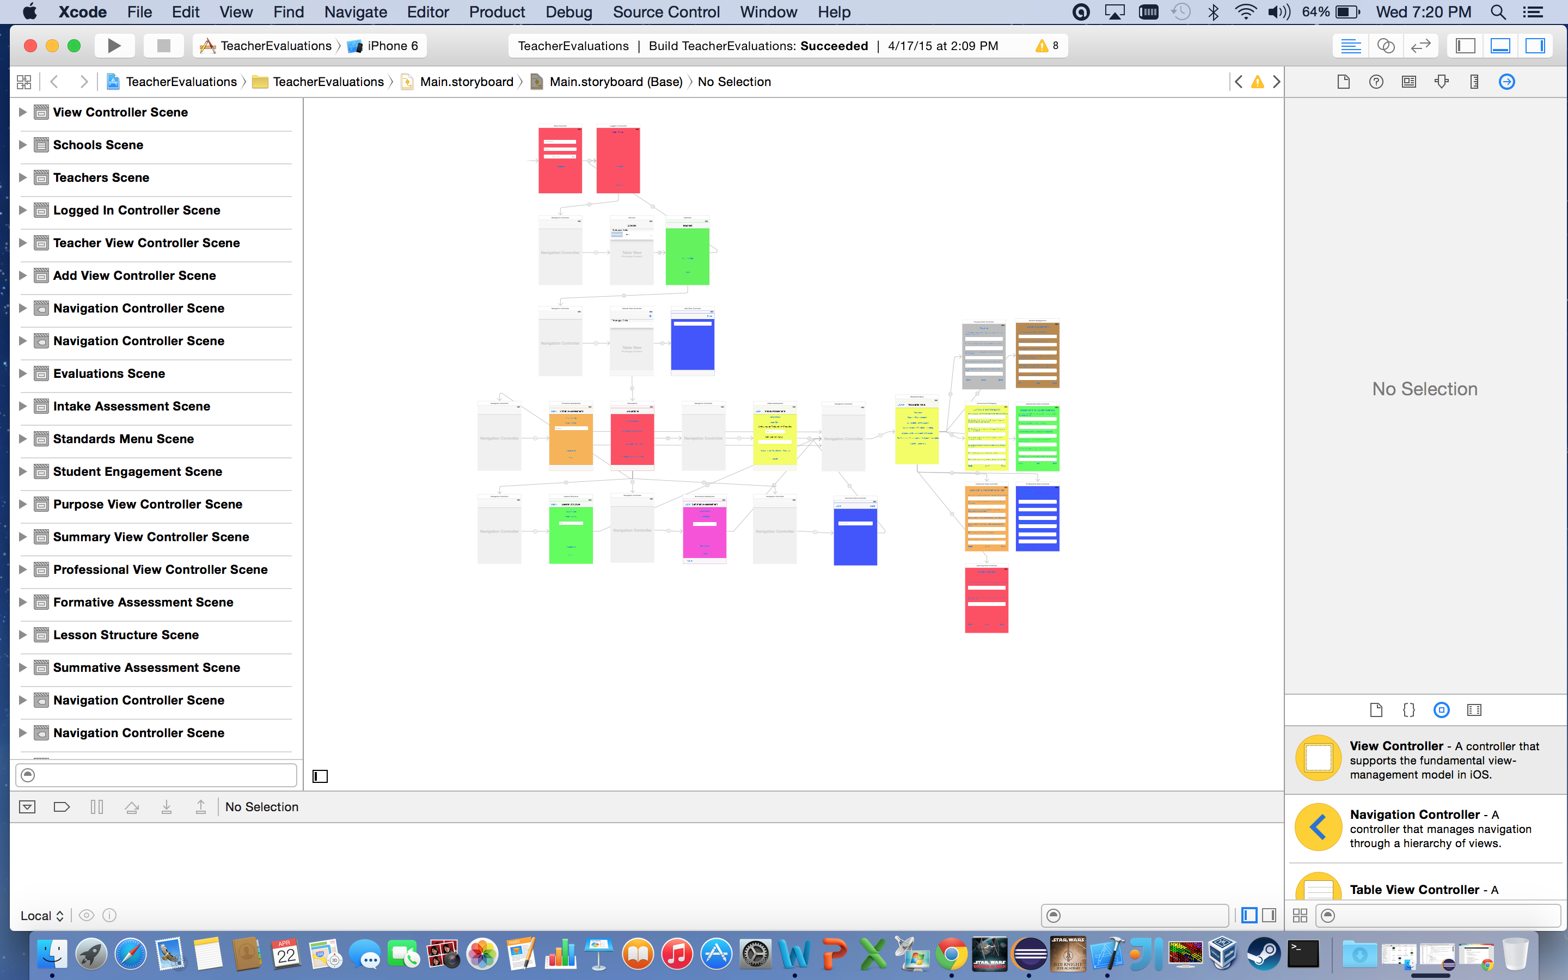

I also had to import many images into a folder for use as background images as well as import libraries from within Xcode to use IOS email functions. I then used code in the viewdidload methods of the objective c files to set the background to an image instead of using the default colors shown in the storyboards.

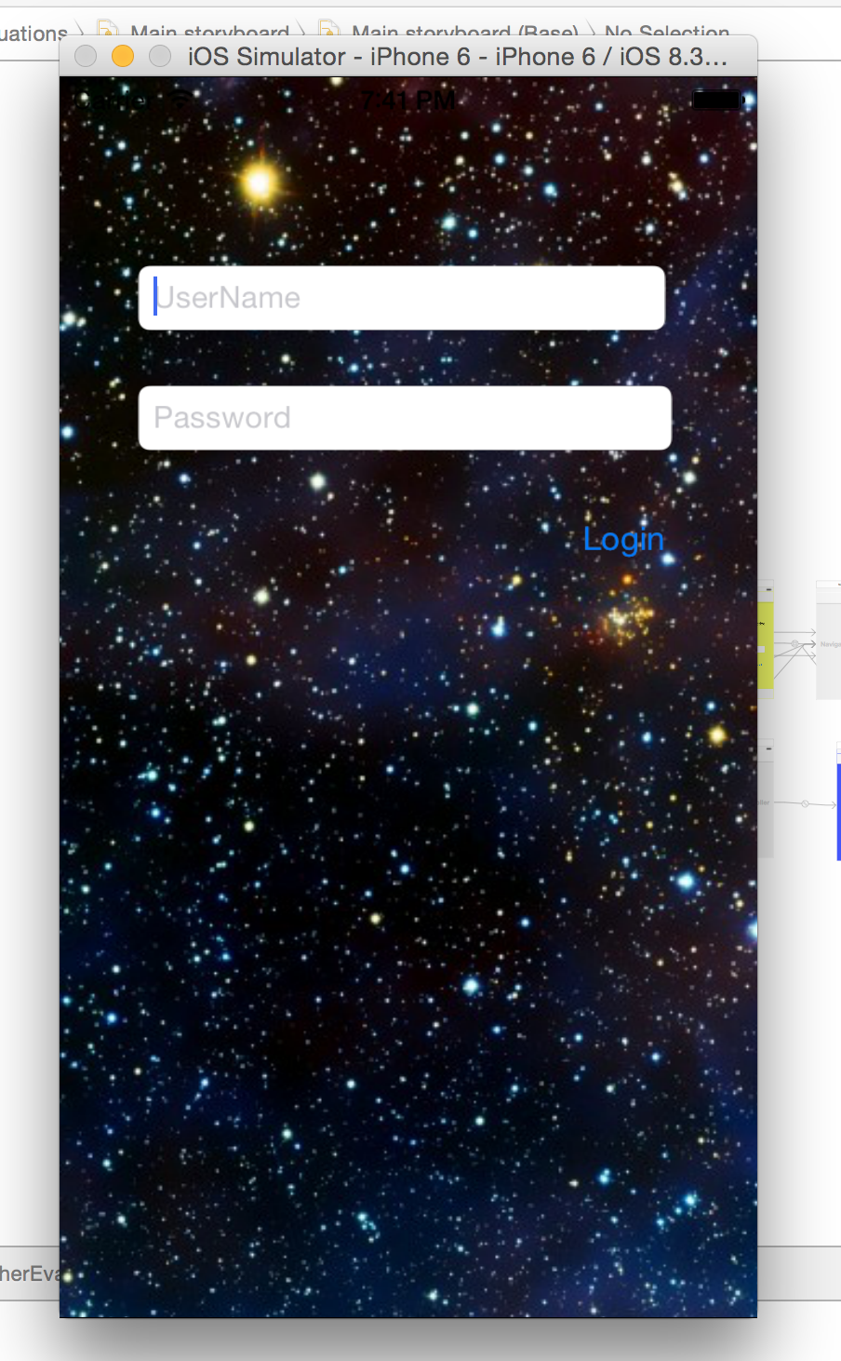

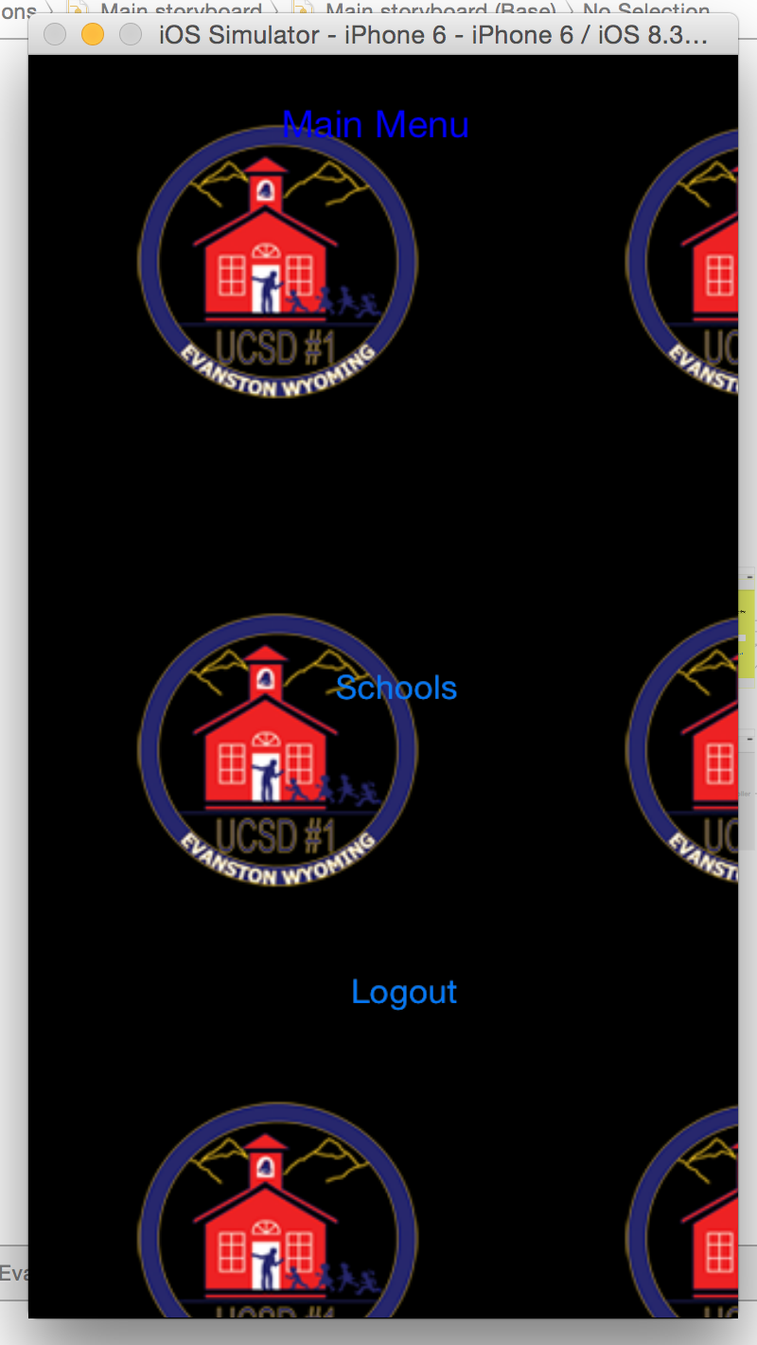

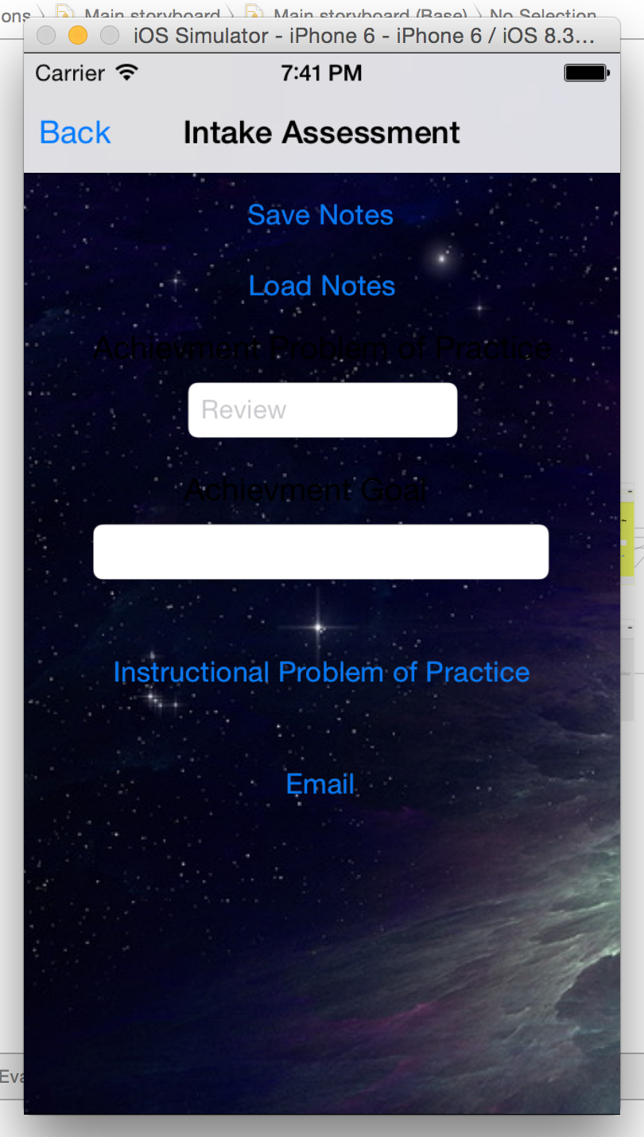

Challenges

One of the most significant challenges when creating this app was learning Objective C and Xcode, as I had only been introduced to Xcode last Mayterm. I would often have to look up online examples of how to use the features of Xcode and often how to do certain things like login a user, use a table view, connect segues between screens, and save and load data. I started programming most of the application last summer, and had a significant amount of the app developed before school started. Later on, the functions that were added during the school year were saving and loading data, as well as email functionality.

The biggest hurdle to overcome was during the final weeks before the senior presentations, when email functions crashed the simulator. I first thought that the problem was with the code I was using, and I tried using multiple ways of implementing email. When I did not seem to be solving the problem, I contacted Chad Zeluff through email to get his opinion on what the issue was. Chad had previously taught the IOS Mayterm class and was the only developer I knew. I sent him an example of the code I was using, and he told me the issue was with the simulator, as it would work on an IOS device. A week before the senior presentations, Apple released a software patch for Xcode that resolved the simulator bug and the app could now simulate sending emails.

I had no IOS device or attachment cable to test my app on an actual device, and thus I currently do not know how the app will work if it was released to the app store. This is one of the many things that I still have left to do, and it also prevented me from testing out the email functions that were hindering my progress.

Achievements

The current application as it is now does most of the functionality my father asks for. It allows a user to log in and register, and the username and password are currently saved. The application also has a table view with all eight schools, and the user has an option to add teachers, edit them, and even delete them from their profile. The important part of the evaluation process is that there are four different evaluations throughout the school year, and a user can go to any of the standards and select a rating or choose not to use it, and save the data and later look at it. Notes can also be taken and used for reference. The email functions will only send written feedback to a teacher and only the principal sees the actual ratings of the app.

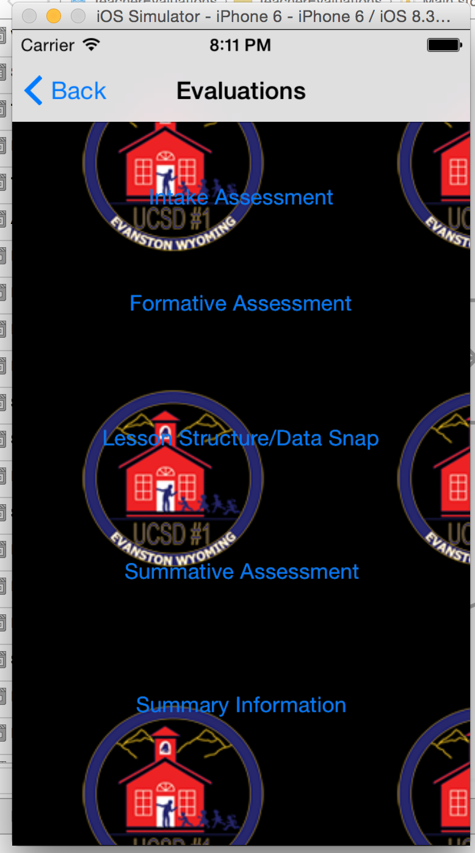

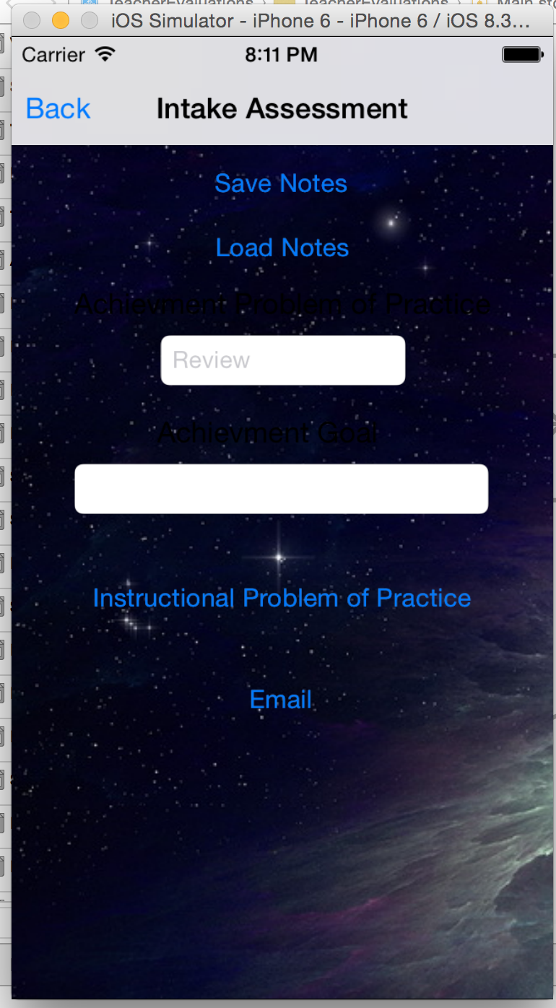

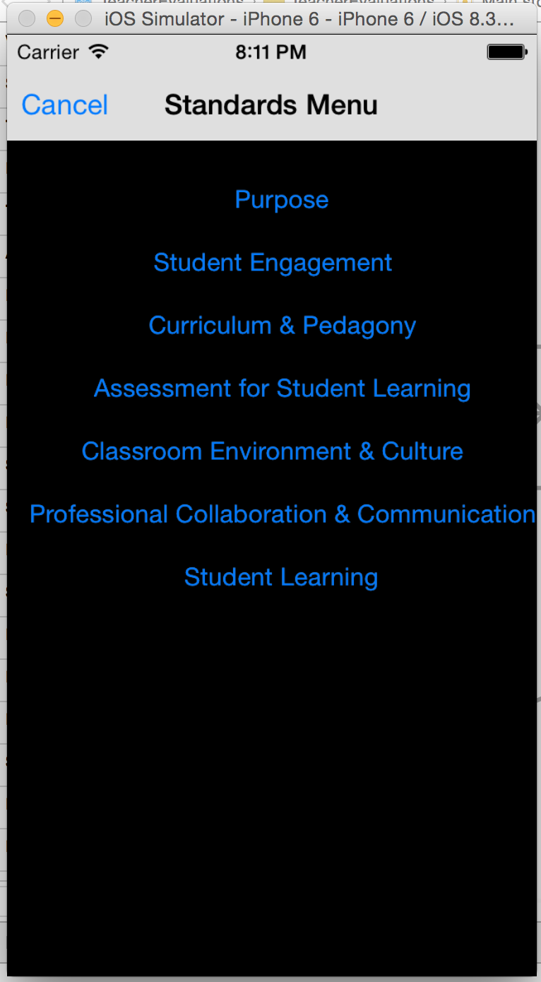

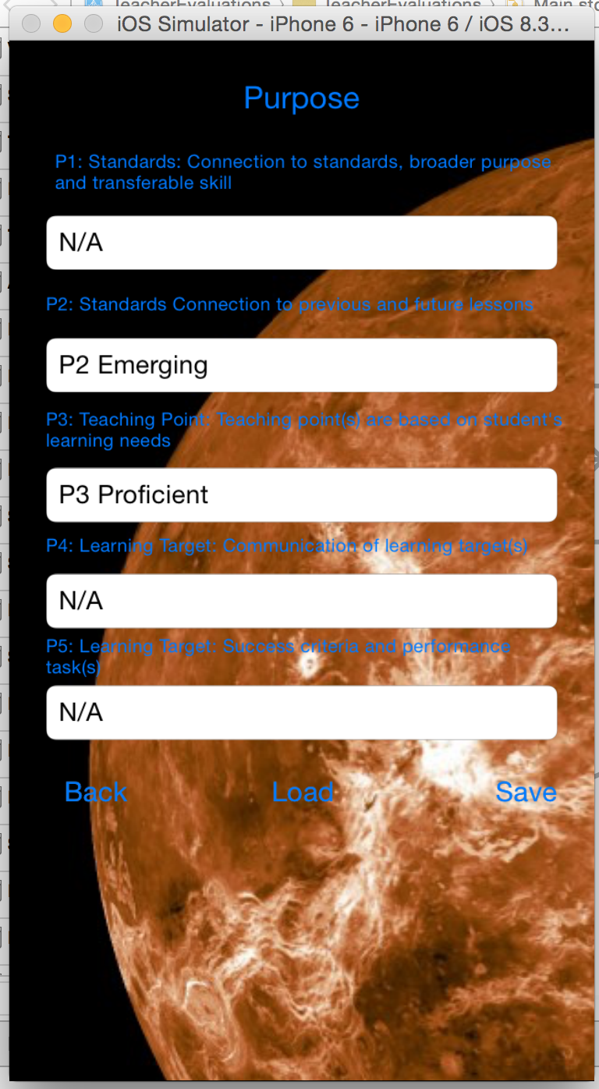

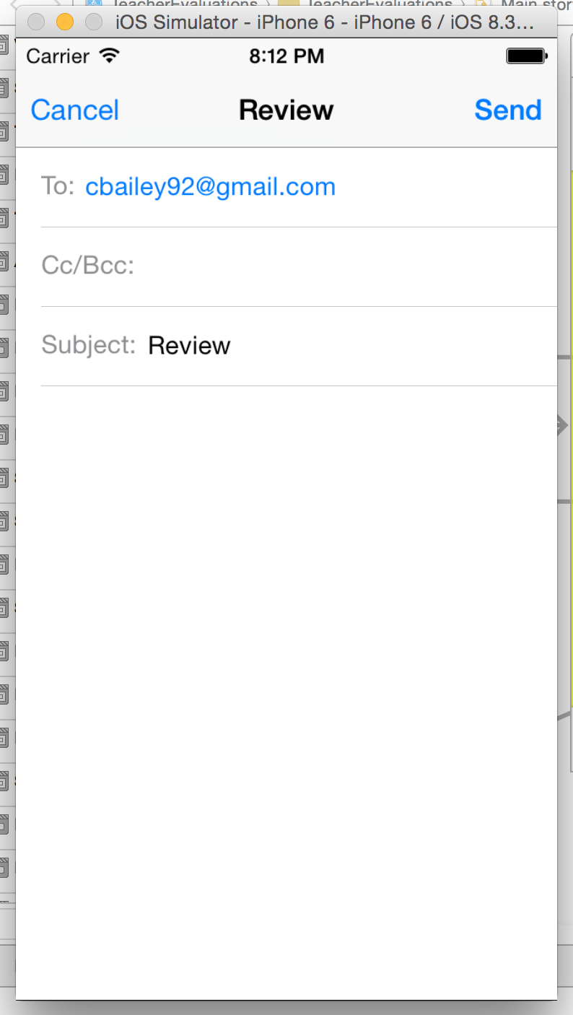

Lessons

Throughout the development of this app, I learned many things. I learned about finding flexibility with using certain approaches, such as the UI menus and saving the text of a rating to use for the rating system. I also learned about how useful it is to design the screens with storyboards and then tie in the screen with a file to make the screen perform certain functionality. This app also gave me an opportunity to learn more about objective C and xcode, and gain experience creating an app.

Surprisingly, the most important lessons I learned were about how to actually meet with customers and develop an app based on their needs. My father had me come to a meeting where his Chief Technology Officer and himself drew out the screens they wanted and described what they wanted me to create. It’s important for a customer to specify what they want out of a software project, as I learned through my summer job at home. If a customer just asks a programmer to make something, the developer has no idea where to start unless they have worked at the company or already know what the user needs. My father would periodically ask for progress reports and I would show him what the application can do and see if the app was fulfilling the school district’s needs. I also learned that sometimes it is alright to take a different approach to implementing functions in software, as there can be a better way of doing it or certain limitations with the development tools.

Features to Add

There are two more features I would want to add in the future. The first is to have the application connect to a database and especially a database owned by the school district. The second would be to have separate files for each teacher and evaluation, as the app currently applies and saves or changes I make to all schools, and teachers, and principals need different files for different occasions.

Most of the tasks that still need to be done are with the users themselves. I will need to show the application to the users, and get feedback on what works and what they want in this app. A possible collaboration between myself and employees in the technology department of Uinta County School District #1 would also be needed if a more experienced IOS developer can assist me in refining the app. Beta testing on an actual device and having the actual users beta test it will also benefit the development process and ensure principals have no major issues once the app is in the app store. The final thing left to do is to get a developer’s license and publish the product to the app store once everyone involved in using the app is satisfied.

Conclusion

Overall, I am very proud of the work that has been done so far. I am glad that I can assign a rating to a standard or not use it , and that a user has flexibility in rating a teacher. I was overjoyed when apple fixed the simulator bug with email and was worried that the app would crash in my presentation. I learned a lot and gained experience with Xcode and Objective C, as well as developing soft skills interacting with customers and showing them what I have created so far. If I ever get into management at a software company, I will be able to related to the software developers and programmers since I created my own app, while being able to vice their concerns to other managers who might not know the difficulties in programming an app. I can effectively lead a team of developers by example having created my own app, and have experience dealing with others who do not program or do anything with implementing actual software.